Crossword – Front Crawl

|  |  |  |  |  |  |  |  |  |  |  |  |
| --- | --- | --- | --- | --- | --- | --- | --- | --- | --- | --- | --- |
| 1. |  |  |  | 2. |  |  |  |  |  |  | |
|  | | | |  |  | | | | | | |
|  | | | 3. |  |  |  | 4. |  | | | |
|  | | | |  |  | |  |  | 6. |  | |
|  | | | |  |  |  |
|  | | | | | | | 5. |  |  |  |  |
|  | | | | | | | | |  |  | |
|  | | | | | | | | |  |  | |
|  | | | | | 7. | 8. |  |  |  |  |  |
|  | | | 10. |  | |  |  | |  |  | |
|  | | |  |  |  |
|  |  |  |
|  | 9. |  |  |  |  |  |  |

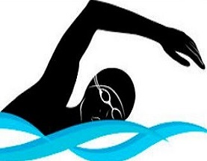

Across = Red Down = Blue

1. The fastest stroke is _ _ _ _ _ _ _ _ _ _.
2. I swim front crawl on my _ _ _ _ _.
3. My splashes should be _ _ _ _ _ when I kick.
4. When swimming front crawl I should always _ _ _ _ forwards.
5. My legs must _ _ _ _ when I swim.
6. The opposite stroke to front crawl is _ _ _ _ _ _ _ _ _ _.
7. Every 3 strokes on front crawl I should _ _ _ _ _ _ _ to the side.
8. As my arms recover over the water I must _ _ _ _ _ forwards.
9. There should be minimal _ _ _ _ _ _ when I swim.
10. My arms _ _ _ _ me through the water