Crossword – Butterfly

|  |  |  |  |  |  |  |  |  |  |  |  |  |
| --- | --- | --- | --- | --- | --- | --- | --- | --- | --- | --- | --- | --- |
|  | 1. |  | 2. |  |  |  | 4. |  |  |  |  |  |
|  |  |  |  |  |  |  |  |  |  |  |  |  |
|  |  |  |  |  |  |  |  |  |  |  |  |  |
|  |  |  |  |  | 5. |  |  |  | 6. |  |  |  |
|  |  |  |  |  |  |  |  |  |  |  |  |  |
|  | 3. |  |  |  |  |  |  |  |  |  |  |  |
|  |  |  |  |  |  |  |  |  |  |  |  |  |
|  |  |  |  |  | 10. |  |  |  |  |  | 8. |  |
|  |  |  |  |  |  |  |  |  |  |  |  |  |
|  |  |  |  |  |  |  |  | 7. |  |  |  |  |
|  |  |  |  |  |  |  |  |  |  |  |  |  |
| 9. |  |  |  |  |  |  |  |  |  |  |  |  |

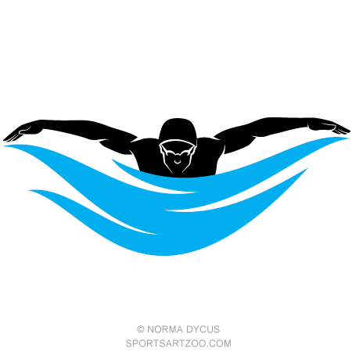

Across = Red Down = Blue

1. Your body should _ _ _ _ _ _ _ _ through the water.
2. Butterfly kick is widely known as _ _ _ _ _ _ _ kick.
3. You must tuck your _ _ _ _ close to your chest.
4. Your legs must stay _ _ _ _ _ _ _ _.
5. The _ _ _ _ is the most important part of the kick
6. When kicking your hips are accompanied by your _ _ _ _ _
7. It is important to _ _ _ _ _ your body when swimming butterfly.
8. Your _ _ _ _ should stay still.
9. You must enter the water with you _ _ _ _ _ _ _ _ _ _ first.
10. As you pull through the water your elbows will act as a _ _ _ _ _.